**General Attenuation Approach for NHD Catchments**

1) Distribute loads to each catchment as done previously (there is a slight change in how streambank-eroded loads are calculated – *see below*). In this case, the input loads are those passed to the API from MMW for each HUC12 basin.

2) For each catchment, calculate the “accumulated” load (i.e., “internal” load plus the “upstream” load). In this case, the “accumulated” loads have to be tracked by each “source” category (i.e., land cover type, groundwater, point source, etc.), and by each HUC12 basin.

3) At each catchment (within each HUC12), calculate the “attenuated” load as:

Attenuated Load = Accumulated Load * (1 – (“ShedAreaDrainLake” * “Retention” factor))

For example, if Accumulated Load for a given catchment = 100,000 kg of sediment, and ShedAreaDrainlake = 0.17, then:

Attenuated Load = 100,000 * (1 – (0.17 * 0.84)) = 100,000 * 0.8572 = 85,720 kg

For the next downstream catchment, the “upstream” load is now the “attenuated” load (i.e., 85,720)

4) For the API, the “ShedAreaDrainLake” value will be calculated using “StreamCat” data associated with each NHD catchment. Specifically, this value (which ranges from 0-1) will be calculated as the total percentage of the catchment comprised of wooded wetland, herbaceous wetland, and water (i.e., ShedAreaDrainLake = PctWdWet2011Cat + PctWdWet2011Cat + PctOw2011Cat). For the initial API, use the default “retention” factors of 0.12, 0.29 and 0.84 for nitrogen, phosphorus, and sediment, respectively. These values will likely change through a process of testing and calibration done using about 100 basins around the country.

*Streambank Load Distribution*

For each NHD catchment, this is calculated as:

SL = (SBS * 0.4 * AreaFrac) + (SBS * 0.6 * PctImpervFrac)

NL = (SBN * 0.4 * AreaFrac) + (SBN * 0.6 * PctImpervFrac)

PL = (SBP * 0.4 * AreaFrac) + (SBP * 0.6 * PctImpervFrac)

Where:

SBS = Total streambank sediment load of watershed

SBN = Total streambank nitrogen load of watershed

SBP = Total streambank phosphorus load of watershed

SL = Streambank sediment load apportioned to a given NHD catchment

NL = Streambank nitrogen load apportioned to a given NHD catchment

PL = Streambank phosphorus load apportioned to a given NHD catchment

AreaFrac = Total area of the NHD / Total area of the HUC12 basin

PctImpervFrac = NHD impervious area / HUC12 impervious area

Phone Call with Barry Evans and Ali 1/10/18

We discussed that at each step the load would be reduced based on the (1 – (“ShedAreaDrainLake” * “Retention” factor)) so of A drains to B and both A and B have a load of 10 and a reduction of .5 then the bottom of B sees 10*.5 * .5 + 10*.5 or 7.5

**Calculation of HUC12 Attenuation for Hay Pasture TN**

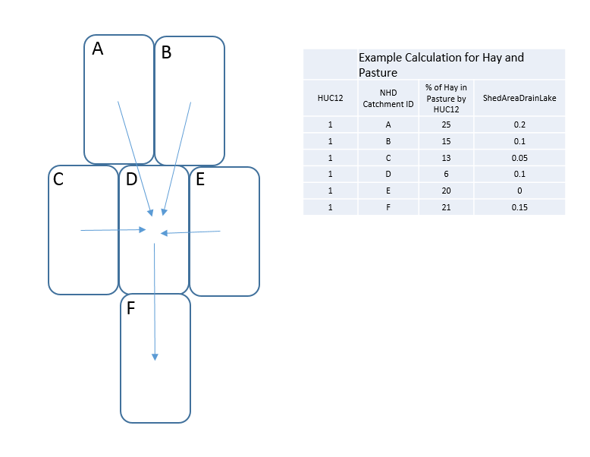

Example 1. Above if the 6(A-F) nhd plus catchments make up HUC12. Then the attenuation coefficient for Total Nitrogen for this HUC12 can be calulated as follows,

1. To make this unitless assume initial HUC12 loading = 1, therefore loading for Each Catchment is just the ration of land area of Hay Pasture for the local Catchment / Total Huc12 Area of Hay Pasture. (Column Three in the above example / 100) . To get the Total Attenuation therefore simply route the percent for all NHDplus catchments down the tree (streams).

Eg.

For A = .25 * (1-(0.2 * 0.84)) * (1-(0.1 * 0.84))* (1-(0.15 * 0.84)) = 0.166521472

For B = .15 * (1-(0.1 * 0.84)) * (1-(0.1 * 0.84))* (1-(0.15 * 0.84)) = 0.1100002416

For C = .13 * (1-(0.05 * 0.84)) * (1-(0.1 * 0.84))* (1-(0.15 * 0.84)) = 0.09970473136

For E = .13 * (1-(0.0 * 0.84)) * (1-(0.1 * 0.84))* (1-(0.15 * 0.84)) = 0.10407592

For D = .06 * (1-(0.1 * 0.84))* (1-(0.15 * 0.84)) = 0.04803504

For F = .21 * (1-(0.15 * 0.84)) = 0.18353999999999998

Total Coef = (0.166521472 + 0.1100002416 + 0.09970473136 + 0.10407592 + 0.04803504 + 0.18353999999999998) = 0.711

To prove the point that the watershed shape matters consider the same starting table with a different shape

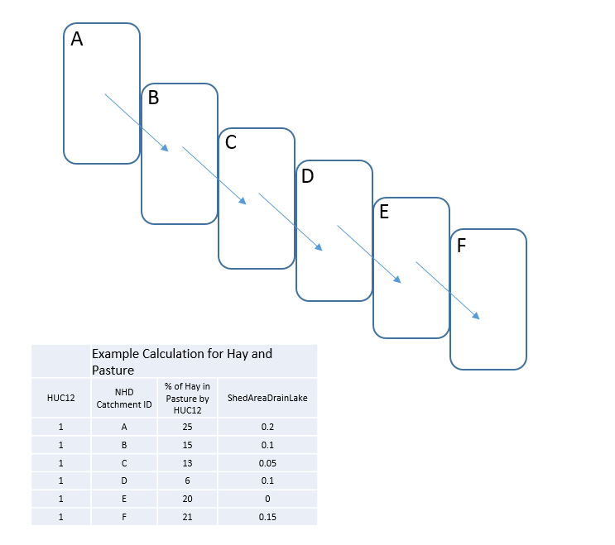

A is now equal to

For A = .25 * (1-(0.2 * 0.84)) * (1-(0.1 * 0.84))* (1-(0.05 * 0.84)) * (1-(0.1 * 0.84)) * (1-(0.0 * 0.84)) * (1-(0.15 * 0.84)) = 0.146127254281216, watersheds that are longer and that tend to have one stream drain into another stream will tend to reduce nutrients more.

Note I can precalculate these values for all huc12’s ahead of time and this will make this a faily trivial process time wise during the api all.